**ML4T – Manual Strategy**

1. **Technical Analysis**

To facilitate the trading strategy, I used 4 technical indicators for this project. The details for these 4 technical indicators is described as follows. Note the stock we use is the JPM stock between January 1, 2008 to December 31, 2009.

1. **Simple Moving Average**

The first technical indicator is based on the simple moving average (hereafter refers to as “SMA”) of the daily close price of underlying stock. At each trading time $t$, $SMA_{t}(n)$ is the arithmetic average of the closed price of the previous $n$ trading days (including time $t$). The technical indicator is constructed as follows:

$$\frac{price_{t}}{SMA_{t}(n)}$$

The technical indicator is the ratio between the adjusted closed price and SMA. When the price crosses above the SMA (i.e. the ratio moves from negative territory to the positive territory), it is deemed as a “Buy” signal; while the price crosses below the SMA (i.e. the ratio drops from positive territory to the negative territory), it is deemed as a “Sell” signal. The graph below illustrated the dynamic of the Price/SMA indicator, which compares the stock price with the 20-day moving average.

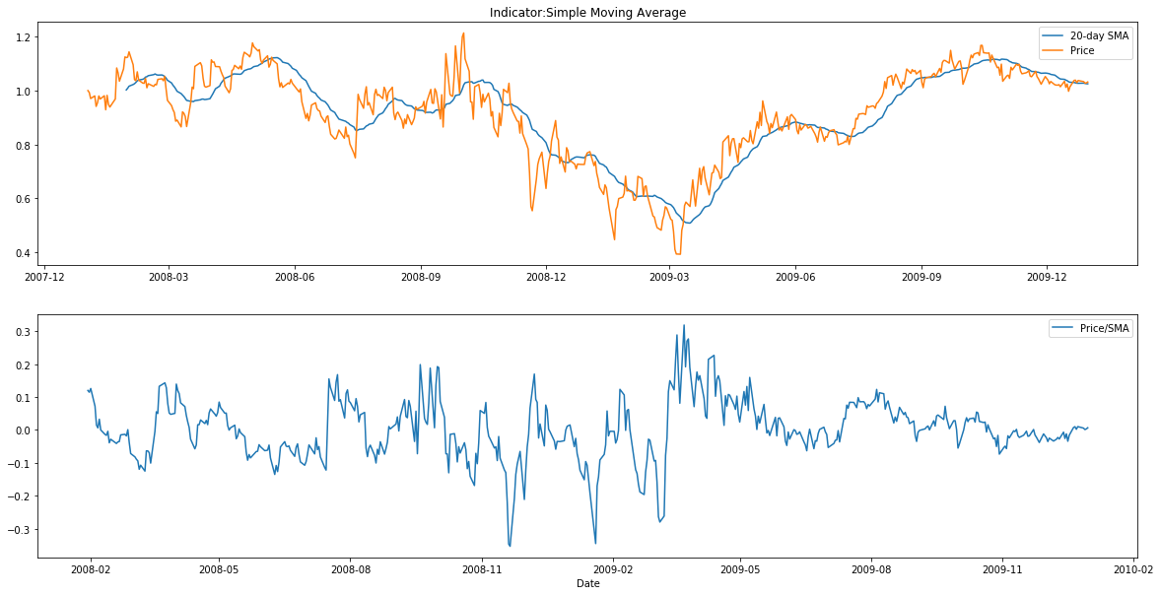

1. **Bollinger Bands**

Bollinger Bands is a volatility indicator. It wraps up bands/boundary around the SMA. The width of the bands is determined by the moving standard deviation of the underlying stock. The construction of the band is summarized as follows:

$$upper band_{t}=SMA_{t}(n)+kσ_{t}(n)$$

$$lower band_{t}=SMA_{t}(n)-kσ_{t}(n)$$

where,

$σ_{t}(n)$ is the moving standard deviation calculated based on the previous $n$ data.

The indicator is constructed based on the Bollinger Bands as follows:

$$BB=(Price_{t}-SMA_{t}\left(n\right))/kσ_{t}(n)$$

When the $BB$ indicator crosses above -1 (i.e. the stock price crosses above the lower band), it is deemed as a “Buy” signal; while the $BB$ indicator crosses below 1 (i.e. the stock price crosses below the upper band), it is deemed as a “Sell” signal. It is a momentum signal, as it assumes the momentum would continuous when the price crossed the SMA line. The graph below illustrated the dynamic of the $BB$ indicator, which compares the stock price with the Bollinger Bands with 20-day moving average and $±$ two 20-day moving standard deviation.

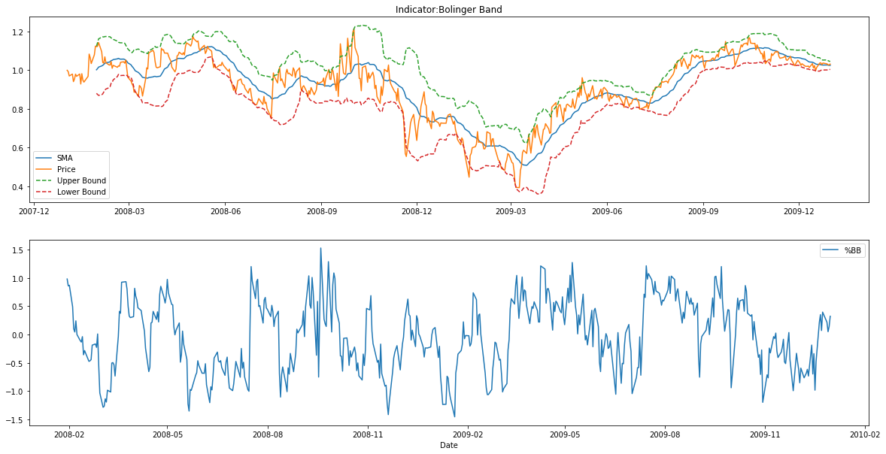

1. **Moving Average Convergence/Divergence**

Moving Average Convergence/Divergence (hereafter refers to as “MACD”) is a trend-following momentum indicator that exhibit the dynamic of two exponential moving average (EMA) of the underlying stocks. The MACD line is constructed by subtracting the long-term ($n_{1}$-day) EMA from the short term ($n_{2}$-day) EMA.

In the project, we employ a trading strategy based on MACD line, which is called signal crossover. Firstly, we construct the signal line by calculate the $m$-day EMA of the MACD line. Then, the indicator is calculated as below:

$$MACD\left(n_{1},n_{2},m\right)=MACD line-signal line$$

When the MACD line crosses above the signal line (i.e. $MACD\left(n_{1},n_{2},m\right)$ moves from negative territory to the positive territory), it is deemed as a “Buy” signal; while the MACD line crosses below the signal line (i.e. $MACD\left(n_{1},n_{2},m\right)$ drops from positive territory to the negative territory), it is deemed as a “Sell” signal. The graph below illustrated the dynamic of the $MACD\left(12,26,9\right)$ indicator, where the shadowed area represents the value of the $MACD\left(12,26,9\right)$ indicator.

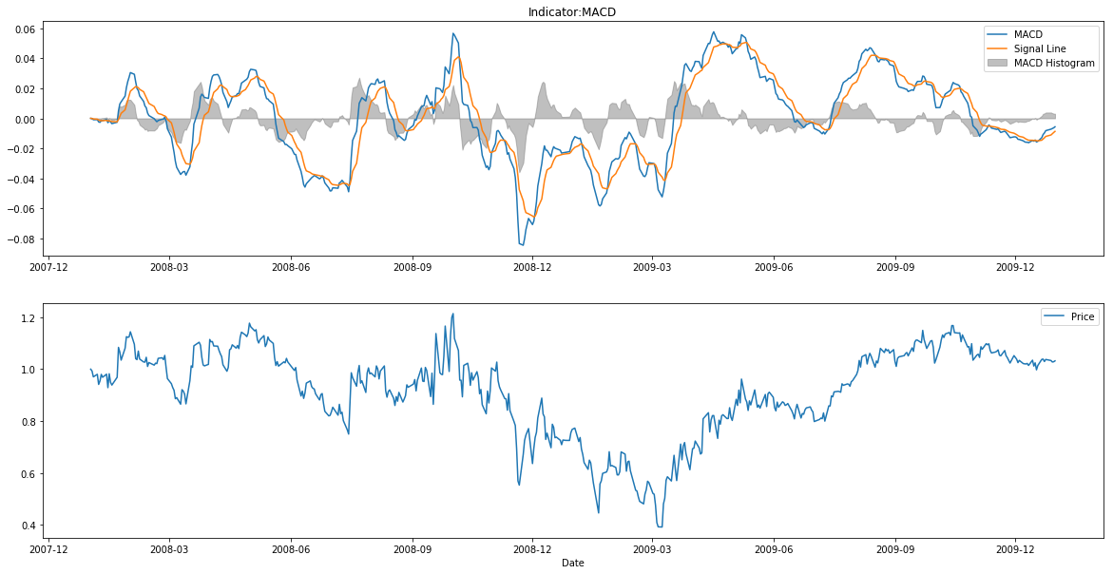

1. **Relative Strength Index**

Relative Strength Index (hereafter refers to as “RSI”) is a momentum indicator that compares the magnitude of recent gains and losses over a specified time period to measure speed and change of price movements of a security.  The construction of RSI is described as follows.

First of all, for each trading period ($N$-day), the upward change $U$ and the downward changes $D$ are calculated respectively.

$$U=\left\{\begin{aligned}\frac{price_{current}}{price_{previous}}-1, price_{current}>price_{previous} \\ 0, price_{current}<price_{previous}\end{aligned}\right.$$

$$D=\left\{\begin{aligned}\frac{price_{current}}{price_{previous}}-1, price_{current}<price_{previous} \\ 0, price_{current}>price_{previous}\end{aligned}\right.$$

The RSI is calculated as follows:

$$RSI=100-\frac{100}{1+RS}$$

where,

$RS$ is the ratio between $N$-day EMA of $U$ and $N$-day EMA of $D$.

To determine the trading signal, we have two thresholds for RSI (usually 70 and 30). When the RSI is above the upper threshold, it indicates that the stock is over-bought, hence it’s a “Sell” Signal; while the RSI is below the lower threshold, it indicates that the stock is over-sell hence it’s a “Buy” Signal. The graph below illustrated the dynamic of the $RSI$ indicator with a 14-day moving window.

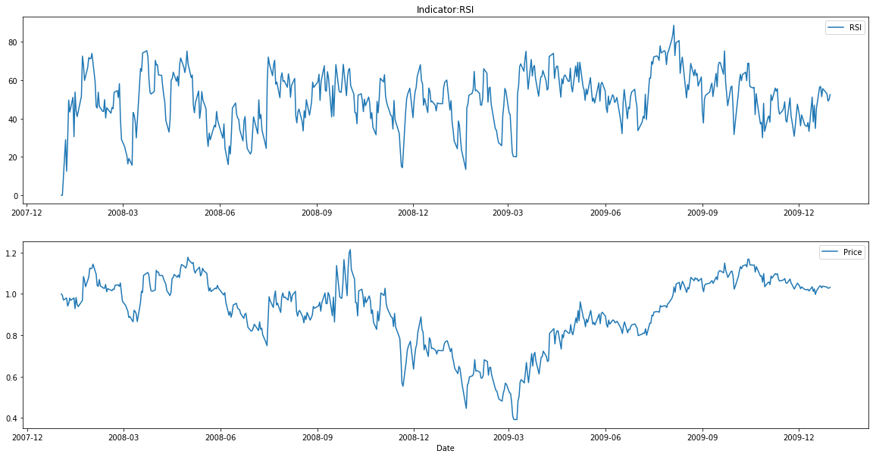

1. **Best Possible Strategy**

In this section, we develop the Best Possible Strategy for trading the JPM stock between the in-sample period, which is between January 1, 2008 to December 31, 2009. It assumes that we know the stock movement in the future during this in-sample period, at the first day of trading. Given this advantage, the strategy is very simple. At each time t, if the price of the next day increases or remain the same, we hold +1000 position (long) of JPM; Otherwise, we hold -1000 position (short) of the underlying stock. This strategy ensures that we always gain money every single day, no matter the underlying price goes up or down. The following graph and table show the comparison of performance between the Best Possible Strategy and the benchmark (i.e. buy and hold +1000 position from day 1). Note there’s no commission fee and impact fee.

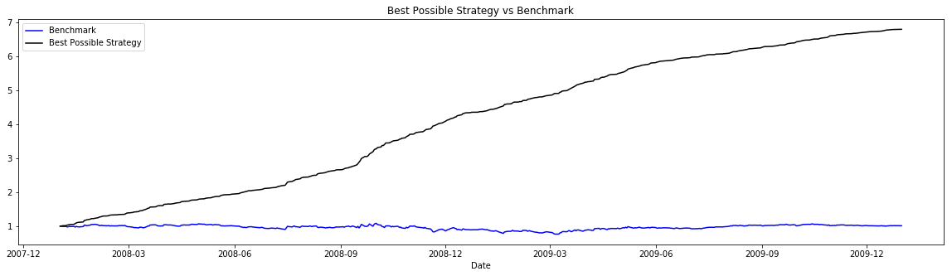

|  |  |  |
| --- | --- | --- |
|  | Benchmark | Best Possible Strategy |
| Cumulative Return | 1.23% | 578.61% |
| Mean of Daily Return | 0.0168% | 0.3817% |
| Standard Deviation of Daily Return | 1.705% | 0.45% |

The above graph shows comparison between the portfolio values of the Best Possible Strategy and the benchmark. The portfolio values of the Best Possible Strategy are consistently higher than that of the benchmark. And the Best Possible Strategy has higher cumulative return, average daily return and lower standard deviation of daily return in the in-sample period.

1. **Manual Strategy**

In this section, we develop the trading strategy using the four technical indicators that we introduced in the first section. For each trading day, we calculate four technical indicators respectively. If any technical indicator shows a “Buy” signal, we assign +1 to this indicator; and if any technical indicator shows a “Sell” signal, we assign -1 to this indicator; otherwise the assignment is zero for that technical indicator. Subsequently, we sum up the assignment of these 4 technical indicator. If the sum is above +2, we hold +1000 position of the underlying stock; if the sum is below -2, we hold -1000 position of the underlying stock; otherwise, we keep the holding as the same as the last trading day.

The reason of implementing this trading strategy is to avoid the single-indictor bias. When majority of the indicator exhibit same direction, it is very likely an authentic “Buy” or “Sell’ opportunity. In addition, this trading strategy decreases the trading frequency, prevent us from spending too much unnecessary trading cost.

Besides, we customize the threshold for the Bollinger Bands indicator and RSI indicator.

1. For the Bollinger Bands, when the $BB$ indicator crosses above – $BB_{threshold}$, it is deemed as a “Buy” signal; while the $BB$ indicator crosses below $BB_{threshold}$, it is deemed as a “Sell” signal[1].
2. For RSI, we set up the upper and lower threshold as $upper_{rsi}$ and $lower_{rsi}$.

Hence, we optimize these three threshold to achieve the largest cumulative return in the in-sample period by implementing the aforementioned trading strategy. The yield thresholds are summarized as follows:

|  |  |  |
| --- | --- | --- |
| $$BB_{threshold}$$ | $$upper_{rsi}$$ | $$lower_{rsi}$$ |
| 1 | 85 | 25 |

Subsequently, we implement the trading strategy using the optimized thresholds for the Bollinger Bands and RSI. The following graph and table show the comparison of performance between the Manual Strategy and the benchmark (i.e. buy and hold +1000 position from day 1) in the in-sample period. Note there’s 9.95 of commission fee per transaction and 0.5% of impact fee.

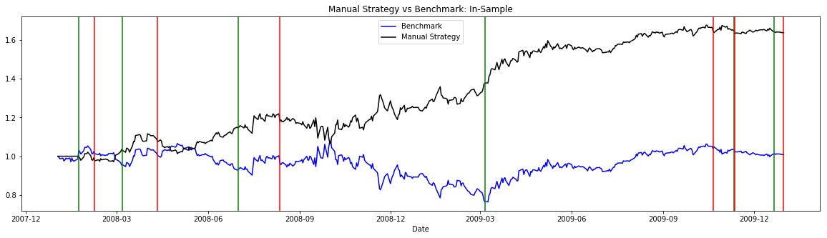

|  |  |  |
| --- | --- | --- |
|  | Benchmark | Best Possible Strategy |
| Cumulative Return | 1.02% | 63.82% |
| Mean of Daily Return | 0.0165% | 0.1062% |
| Standard Deviation of Daily Return | 1.704% | 1.284% |

The above graph shows comparison between the portfolio values of the Manual Strategy and the benchmark. The green vertical line represents the long position (hold +1000 stock), while red vertical line represents the short position (hold -1000 stock). For most of the time, the portfolio values of the Manual Strategy are consistently higher than that of the benchmark. And the Manual Strategy outperforms the benchmark with respect to every aspect. It has higher cumulative return, average daily return and lower standard deviation of daily return in the in-sample period.

1. **Comparison Analysis**

In this section, we apply the exactly same trading strategy to the out-of-sample date (i.e. between January 1, 2010 to December 31, 2011), as we described in the last section, without adjusting the threshold or tweaking the trading strategy. The thresholds for the Bollinger Bands and the RSI remain the same. The following graph and table show the comparison of performance between the Manual Strategy and the benchmark (i.e. buy and hold +1000 position from day 1) in the out-of-sample period. Note there’s 9.95 of commission fee per transaction and 0.5% of impact fee.

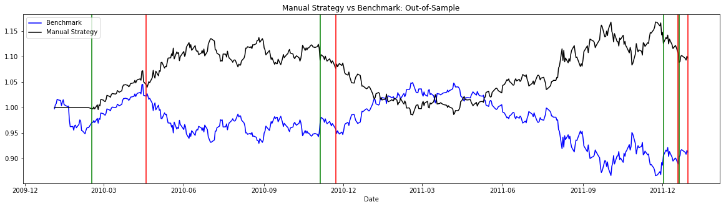

|  |  |  |
| --- | --- | --- |
|  | Benchmark | Best Possible Strategy |
| Cumulative Return | -8.53% | 9.74% |
| Mean of Daily Return | -0.0141% | 0.0211% |
| Standard Deviation of Daily Return | 0.850% | 0.725% |

As shown in the table and graph above, for the out-of-sample period, the performance of the trading strategy still outshines the performance of the benchmark. However, the outperformance is not as significant as the comparison in the in-sample period.

The training of the trading strategy only focuses on to a particular set of data (i.e. the in-sample data), setting the indicator threshold to achieve the highest cumulative return in favor of the in-sample data. Therefore, it relatively underperforms to fit the out-of-sample data set, which is not used for trading strategy training (probably overfitting!).

1. It is equivalent to adjust the width of the Bollinger Band by changing the amount of standard deviation.